[Remove after reading: This ES is for passport holders born in America. Correct and remove green highlighted areas & leave the yellow highlighted areas as is, except to change the highlighted Nationality on page 8 and highlight correct one with yellow]
Fname Mname Lname
THESE EXPLANATORY STATEMENTS ARE TO REMAIN WITH AND ATTACHED TO THIS PASSPORT APPLICATION IN ORDER FOR THIS PASSPORT APPLICATION TO BE TRUE AND CORRECT UNDER PENALTY OF PERJURY UNDER THE LAWS OF THE UNITED STATES OF AMERICA.
c/o Street Address
City, State Domicile, America [Zip]

PASSPORT EXPLANATORY STATEMENTS

These Explanatory Statements will remain as a part of this passport application to obtain my united States passport.

I am returning this United States Passport to this Passport Authority, because the application for it had errors concerning my proper State Citizenship. I NOW have new information about my Florida State Citizenship and I am now reapplying for a new passport with proper information about my Status as a Florida State Citizen.

The DS-11 application seems to be for a U.S. (federal) citizen and does not support an oath or affirmation concerning my proper State Citizenship and Nationality. I am applying for a united States of America Passport with correct information as a native born New Yorker and Florida State Citizen.

I am making a distinction between the Constitutional State Citizen;

Constitution for the United States of America, the Seventeenth Day of September in the Year of our Lord one thousand seven hundred and Eighty seven and of the Independence of the United States of America the Twelfth, Article 4 Section 2a; “The Citizens of each State shall be entitled to all Privileges and Immunities of Citizens in the several States.”

and the U.S. Federal (14th Amendment) citizen, make no mistake, I am NOT a 14th Amendment Federal citizen “Subject to the jurisdiction thereof.” The U.S. State Department may recognize me as a State Citizen (Florida). In addition, my Right to a united States Passport comes from my habitation and domicile and my Natural Right being born in one of the sovereign states of the union; New York. (See enclosed New York State Birth Certificate acknowledging the same and "outside" of any corporate city municipality).

Please review copy of letter from: Susan Bozinko; Acting Director of Legal Affairs and Law Enforcement Liaison

NOTE THE FOLLOWING CONCERNING YOUR REQUEST FOR SSN:

[SOCIAL SECURITY ADMINISTRATION NUMBER FOR FNAME MI LNAME: 123-45-6789]

I believe that the passport application form is in error, as it requests a social security number under the authority of
Section 6039E of the Internal Revenue Code of 1986. Please be advised that no such authority exists within Section 6039E of the Internal Revenue Code of 1986. This section 6039E(b)(1) requires that anyone with a TIN (if any) provide said number. A TIN is for those who are engaged in a trade or business within the United States. Therefore, I am exempt from this requirement pursuant to Section 6039E(e). See attachment, and further;

Also, Section 7 of the Privacy Act of 1974 specifically provides that it shall be unlawful for any Federal, State or Local government agency to deny to any individual any right, benefit, or privilege provided by law because of such individual’s refusal to disclose his/her social security number.

Privacy Act, 1974, Section 7

(a)(1) It shall be unlawful for any Federal, State or local government agency to deny to any individual any right, benefit, or privilege provided by law because of such individual’s refusal to disclose his or her social security number. Pub, L.93-579, Section 7; 5 U.S.C. Sec. 552a. Note unless: (2) Disclosure is required by federal statute for welfare recipients to obtain and provide SSNs of children.

Section (b) Any Federal, State or local government agency which requests an individual to disclose his social security account number shall inform that individual whether that disclosure is mandatory or voluntary, by what statutory or other authority such number is solicited, and what uses will be made of it.

In addition, the citation of 22 USC 2714a: Revocation or denial of passport in case of certain unpaid taxes; is a misapplication of authority because this pertains to “certain cases” of unpaid taxes for US (federal) citizens. There are no unpaid taxes owed or due the IRS.

PLEASE NOTE THE FOLLOWING CONCERNING MY PROPER NATIONALITY AND CITIZENSHIP:

The facts of my birth (Brooklyn, New York, America) and with documents I am submitting, determine that my nationality is New Yorker being born in New York State and according to the U.S. Government printing Office Style Manual, in section: 5.23 - In designating the natives of the States, the following forms will be used, and should be reflected on my passport in the section on “Nationality” - “New Yorker” as opposed to “UNITED STATES OF AMERICA” and therefore, I am a Citizen of the united States* of America, NOT the same as a U.S. (federal) citizen, and entitled to a passport.

I am NOT a “Fourteenth Amendment citizen, born or naturalized in the United States, and subject to the jurisdiction thereof”. I am a Citizen of Florida, being an inhabitant and having my domicile in Florida and therefore a Citizen of these united States* of America, as I stated in my passport application.

PLEASE NOTE: The Supreme Court has officially defined the key term "United States" to have three separate and distinct meanings: [Hooven & Allison Co. vs. Evatt, 324 U.S. 652 (1945)]

  - It may be the name of a sovereign occupying the position of other sovereigns in the family of nations.
  - It may designate the limited territory over which the sovereignty of the United States (Federal Government) extends.
*(3) It may be the collective name for the fifty States, which are united by and under the U.S. Constitution.

A person who is a citizen of the United States (Federal government; Fourteenth Amendment citizen) is necessarily a citizen of the particular state in which he resides. But a person may be a citizen of a particular state and not a citizen of the United States(Federal government; Fourteenth Amendment citizen). To hold otherwise would be to deny to the state the highest exercise of its sovereignty, - the right to declare who are its citizens.
[State v. Fowler, 41 La. Ann. 380] [6 S. 602 (1889), emphasis added]

It is quite clear, then, that there is a citizenship of the United States (Federal government; Fourteenth Amendment citizen) and a citizenship of a State, which are distinct from each other and which depend upon different characteristics or circumstances in the individual.
[Slaughter House Cases, 83 U.S. 36]
[(1873) emphasis added]

There is a distinction between citizenship of the United States (Federal government; Fourteenth Amendment citizen) and citizenship of a particular state, and a person may be the former without being the latter.
[Alla v. Kornfeld, 84 F.Supp. 823] [(1949) headnote 5, emphasis added]

I also believe that the Declaration of Oath Section of the passport application is written in error. I am a Citizen of these united States* of America, not the same as a U.S. citizen and both of my parents were not (federal) U.S. citizens (Section 10).

EXPLANATORY STATEMENT: My Oath with the Proper use of the words “United States” and “Citizen”

I declare under penalty of perjury under the laws of the United States* of America (28 USC 1746 (1)) all of the following: 1) I am a Citizen of the united States* of America, being a New Yorker (by natural birth) and have not, since and acquiring State Citizenship (by birth and proper habitation in one of the sovereign states of the Union) performed any of the acts listed under “Acts or Conditions” on page four of the instructions of this [the] application; 2) the statements made on the application are true and correct; 3) I have not knowingly and willfully made false statements or included false documents in support of this application; 4) the photograph submitted with this application is a genuine, current, photograph of me; and 5) I have read and understood the warning on page one of the instructions to the application form.

*The collective name for the fifty States, which are united by and under the United States Constitution
for America. (NOT the Federal Government)

As you well know, the Constitution for the united States of America is the supreme law of the land and as I stated in my passport application: DECLARATION: Pursuant to 28 USC 1746(1), I declare under penalty of perjury under the Laws of the United States of America that the statements made on this passport application and within this statement are true, correct.

Title 28 Sec. 1746. Unsworn declarations under penalty of perjury

(1) If executed without the United States (Federal government): ''I declare (or certify, verify, or state) under penalty of perjury under the laws of the United States of America that the foregoing is true and correct. Executed on (date). (Signature)''.

And as provided by law, I claim no privileges or immunities provided by the 14th Amendment to the Constitution; not being a citizen subject to the jurisdiction thereof.

Note: Although there may have, been a Social Security number issued in my name and using a State driver license as a form of identification, the use of such documents shall not imply that I am a U.S. (federal) citizen. In addition, the “Permanent Address” in section 19 of the DS-11 is my habitation and domicile and not an address for mailing purposes.

I also wish to make it clear that I am not a statutory citizen and make no claim of statutory citizenship created by any State or Federal government. I hereby extinguish, rescind, revoke, cancel, abrogate, annul, nullify, discharge, and make void ab initio all signatures belonging to me, on all previously filed SS-5, Internal Revenue Service; W-2 Forms, 1040 Forms and all State Income Tax Forms (if any) and all powers of attorney, real and/or implied, connected thereto on the grounds that my purported consent was voluntary and freely obtained, but was made through mistake, duress, fraud, and undue influence exercised by any or all governments (State or Federal) any agency and/or employers. Pursuant to Contract Law; “all previously signed Federal and State forms are, hereby, extinguished by this rescission”.

Any alleged consent is null and void as it was given under duress, by mistake, and/or by fraud. Notwithstanding any information which you may have to the contrary, any forms that have been filed, and any implied quasi contracts that you may have with me, were filed illegally and unlawfully and are without force and/or effect.

I further revoke, rescind and make void ab initio all powers of attorney pertaining to me for any and all governmental, quasi, colorable agencies and/or Departments created under the authority of Art. I, Sec. 8, Cl. 17, and/or Art. IV, Sec. 3, Cl. 2 of the Constitution for the United States.

I preserve all of my unalienable Rights that are inherent from my Creator, at all times.

Pursuant to 28 USC 1746(1), I declare under penalty of perjury under the Laws of the United States of America that the statements made on this passport application and within this statement are true, correct.

With explicit Reservation of All Rights, Without Prejudice, Non Assumpsit, without the United States 28 USC 1746 (1)

__________________________________________
Fname Mname Lname
City, State Domicile, America

CERTIFICATE OF ACKNOWLEDGMENT

_______________________________ State )
) For Verification Purposes Only
_______________________________County )

I hereby certify that on this ______day of __________________, 2017

Fname Mname Lname, whom I know (or has satisfactorily proved to me), appeared to attest and affirm that he/she is the Citizen executing the forgoing document. I, THEREFORE, set forth my hand a seal in affirmation the execution thereof.

____________________________________ __________________
NOTARY Date

____________________________________
My Commission Expires Notary Seal

Documentation Enclosure(s)
Passport Application (DS-11)
Certificate of Birth from New York
Title 28 Section 1746 (1)
Title 26 Sec. 6039E. Information Concerning Resident Status
Title 5 Sec. 552a. Records Maintained on Individuals
U.S. Government Printing Office Style Manual, Section 5.23
Copy of Letter from Susan Bozinko; Acting Director of Legal Affairs and Law Enforcement Liaison; USDOS

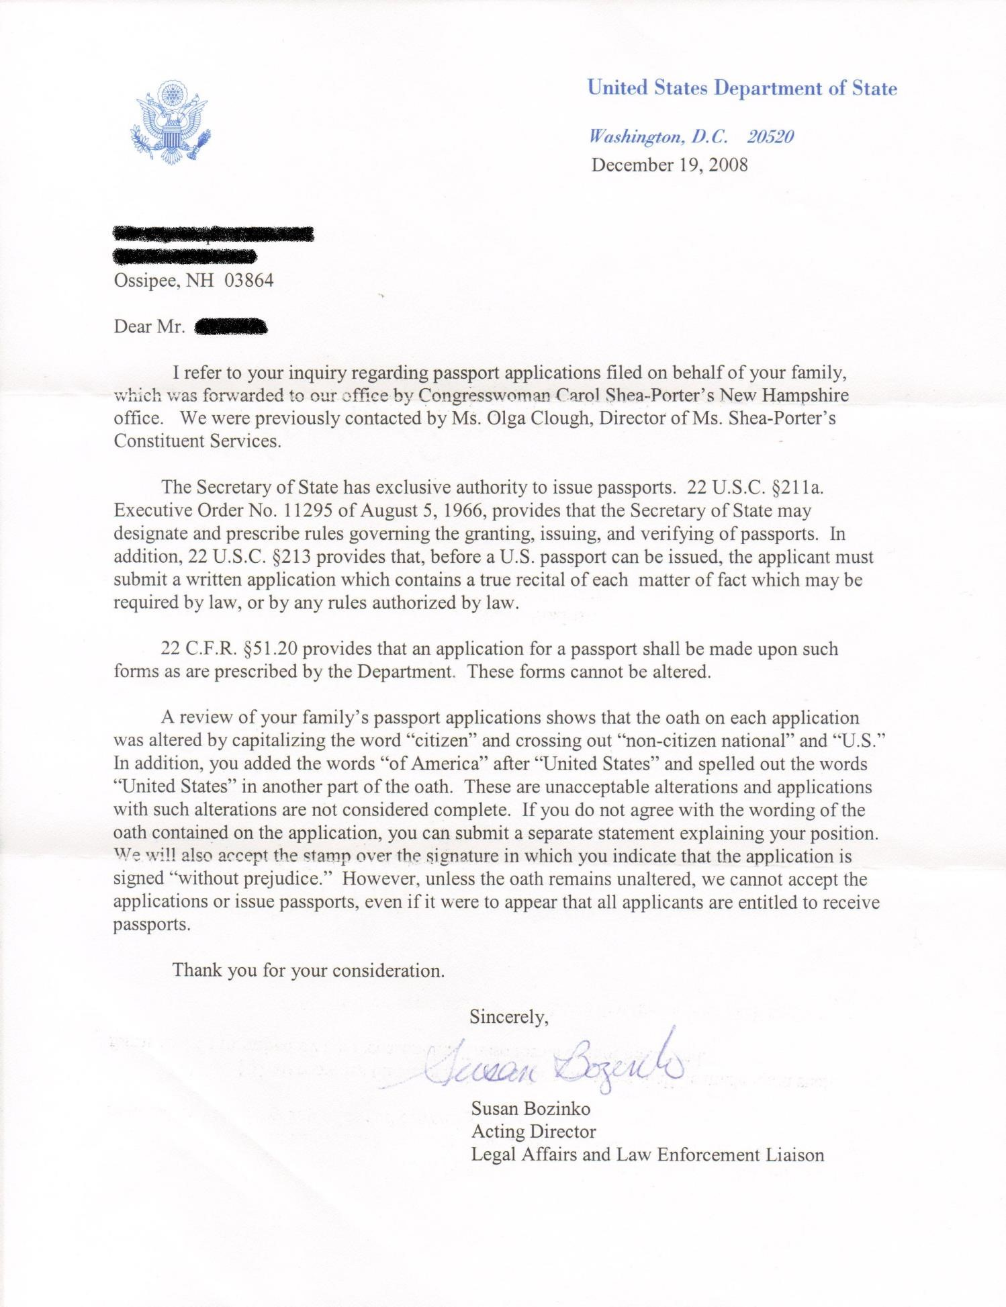

TITLE 26 > Subtitle F > CHAPTER 61 > Subchapter A > PART III > Subpart A > § 6039E
§ 6039E. Information concerning resident status

(a) General rule
Notwithstanding any other provision of law, any individual who—
(1) applies for a United States passport (or a renewal thereof), or
(2) applies to be lawfully accorded the privilege of residing permanently in the United States as an immigrant in accordance with the immigration laws, shall include with any such application a statement which includes the information described in subsection (b).

(b) Information to be provided
Information required under subsection (a) shall include— (1) the taxpayer’s TIN (if any),
(2) in the case of a passport applicant, any foreign country in which such individual is residing, (3) in the case of an individual seeking permanent residence, information with respect to whether such individual is required to file a return of the tax imposed by chapter 1 for such individual’s most recent 3 taxable years, and
(4) such other information as the Secretary may prescribe.

(c) Penalty
Any individual failing to provide a statement required under subsection (a) shall be subject to a penalty equal to $500 for each such failure, unless it is shown that such failure is due to reasonable cause and not to willful neglect.

(d) Information to be provided to Secretary
Notwithstanding any other provision of law, any agency of the United States which collects (or is required to collect) the statement under subsection (a) shall—
(1) provide any such statement to the Secretary, and
(2) provide to the Secretary the name (and any other identifying information) of any individual refusing to comply with the provisions of subsection (a).
Nothing in the preceding sentence shall be construed to require the disclosure of information which is subject to section 245A of the Immigration and Nationality Act (as in effect on the date of the enactment of this sentence).

(e) Exemption
The Secretary may by regulations exempt any class of individuals from the requirements of this section if he determines that applying this section to such individuals is not necessary to carry out the purposes of this section.

5 USC Sec. 552a
01/16/96
TITLE 5 - GOVERNMENT ORGANIZATION AND EMPLOYEES
PART I - THE AGENCIES GENERALLY
CHAPTER 5 - ADMINISTRATIVE PROCEDURE
SUBCHAPTER II - ADMINISTRATIVE PROCEDURE
Sec. 552a. Records maintained on individuals

DISCLOSURE OF SOCIAL SECURITY NUMBER
Section 7 of Pub. L. 93-579 provided that:
''(a)(1) It shall be unlawful for any Federal, State or local government agency to deny to any individual any right, benefit, or privilege provided by law because of such individual's refusal to disclose his social security account number.
''(2) the (The) provisions of paragraph (1) of this subsection shall not apply with respect to -
''(A) any disclosure which is required by Federal statute, or
''(B) the disclosure of a social security number to any Federal, State, or local agency maintaining a system of records in existence and operating before January 1, 1975, if such disclosure was required under statute or regulation adopted prior to such date to verify the identity of an individual.

''(b) Any Federal, State, or local government agency which requests an individual to disclose his social security account number shall inform that individual whether that disclosure is mandatory or voluntary, by what statutory or other authority such number is solicited, and what uses will be made of it.''

U.S. Government Printing Office Style Manual A service of the U.S. Government Printing Office.

https://www.gpo.gov/fdsys/pkg/GPO-STYLEMANUAL-2008/pdf/GPO-STYLEMANUAL-2008-7.pdf
Page: 93 of the Manual or 15 of the PDF

Nationalities, etc.

5.22. The table on Demonyms in Chapter 17 ``Useful Tables'' shows forms to be used for nouns and adjectives denoting nationality.

5.23. In designating the natives of the States, the following forms will be used.

Alabamian Louisianian Ohioan
Alaskan Mainer Oklahoman
Arizonan Marylander Oregonian
Arkansan Massachusettsan Pennsylvanian
Californian Michiganian Rhode Islander
Coloradan Minnesotan South Carolinian
Connecticuter Mississippian South Dakotan Delawarean Missourian Tennessean
Floridian Montanan Texan
Georgian Nebraskan Utahan
Hawaiian Nevadan Vermonter
Idahoan New Hampshirite Virginian
Illinoisan New Jerseyan Washingtonian
Indianian New Mexican West Virginian
Iowan New Yorker Wisconsinite
Kansan North Carolinian Wyomingite
Kentuckian North Dakotan

28 USC Section 1746 Unsworn declarations under penalty of perjury

Wherever, under any law of the United States or under any rule, regulation, order, or requirement made pursuant to law, any matter is required or permitted to be supported, evidenced, established, or proved by the sworn declaration, verification, certificate, statement, oath, or affidavit, in writing of the person making the same (other than a deposition, or an oath of office, or an oath required to be taken before a specified official other than a notary public), such matter may, with like force and effect, be supported, evidenced, established, or proved by the unsworn declaration, certificate, verification, or statement, in writing of such person which is subscribed by him, as true under penalty of perjury, and dated, in substantially the following form:
- (1) If executed without the United States: ''I declare (or certify, verify, or state) under penalty of perjury under the laws of the United States of America that the foregoing is true and correct. Executed on (date). (Signature)''.
- (2) If executed within the United States, its territories, possessions, or commonwealths: ''I declare (or certify, verify, or state) under penalty of perjury that the foregoing is true and correct. Executed on (date). (Signature)''.

