JACKSON COUNTY RECORDING DISTRICT

SCOTT LEBRAND MARTIN, FOREIGN GRANTOR Scott LeBrand Martin, American State Grantee

Deed of Land Recording

Extension of County, State & Land Recording # from the Father’s Deed of Re-Conveyance

Return to: Martin, Scott LeBrand, Administrator
c/o 17789 Highway 12
Black River Falls, Wisconsin [54615]

This cover sheet has been added to these recorded documents to provide space for the recording data.
This cover sheet appears as the first page of the document in the official public record.
Do not detach.

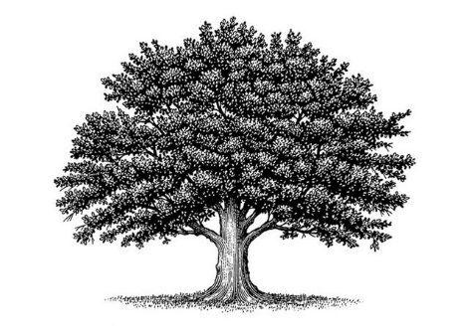
Deed of Land Recording
[Child’s Private Identity Code – use the # from a registered letter label]
American Common Law Copyright and Trademark of Trade Name

On the ___ day of __________ in the year ________ Anno Domini at the hour and minute of _________ a.m./p.m., a new baby was born on the land of _________________ County in the _____________________State to the __________________Family and was given the name: _______________________________________.

The private natural biological parents are: __________________________________, Father, born ___________ on the land of the ________________________County, ___________________State and ____________________________ Mother, born ___________________________, on the land of ______________County , ___________________State [ ].

The family lives in the ________________________County, ____________________State and keeps their mailing address c/o ______________________________________________________ [zip code].

This baby is their ________ living child and ______________ son or daughter (select one).

Witness Jurat
In Witness of these facts, before me, a Public Notary, appeared _______________________________ a private natural person and did present proofs of their identity and was deposed and did swear to or affirm these facts from Without the United States and did proclaim them under penalty of perjury and did sign this Deed in confirmation of all the above:
By:_______________________________________Witness
By:_______________________________________Notary
My commission expires on:___________________. Notary Seal

EXAMPLE OF HOW A FINISHED DOCUMENT LOOKS except for autographs

Deed of Land Recording: 5 MKO 2 49987 USA
American Common Law Copyright and Trademark of Trade Name
On the 14th day of May in the year 2017 Anno Domini at the hour and minute of 10:05 a.m., a new baby was born on the land of Jackson County, Wisconsin State to the Martin Family and was given the name: Genevieve Clementine Martin.

The private natural biological parents are: Scott LeBrand Martin, Father, born November 6, 1985, on the land of the Wahatchee County, Idaho State & Jeanine Lucille (Morgan) Martin, Mother, born April 6, 1990, on the land of the Hillsboro County, Maine State.

The family lives in Jackson County, Wisconsin State and keeps their mailing address c/o 17789 Highway 12, Black River Falls, Wisconsin [54615].

This baby is their second living child and first daughter.

Witness Jurat
In Witness of these facts, before me, a Public Notary, appeared Scott LeBrand Martin, a private natural man and did present proofs of their identity and was deposed and did swear to or affirm these facts from Without the United States and did proclaim them under penalty of perjury and did sign this Deed in confirmation of all the above:
By:_____________________________________Witness
By:_____________________________________Notary Seal
My commission expires on:___________________.

